**Simulated annealing**

The term simulated annealing is analogous to the real world physical annealing with solids, in which it is heated for certain temperature and allowed to cool slowly until it gets the desired crystal shape. In the same way in simulated annealing, we are trying to find a global minimum (minima) for the descript optimization problem such as **travel salesman problem (TSP)** via iterated optimization search algorithm of simulated annealing.

**Local optima**

**Local optima** are the local minimum points as it is shown in the figure below. It is the point at which the negative gradient is changed to the positive one. In simulated annealing we are trying to search for the global optima, which is the global minimum point.

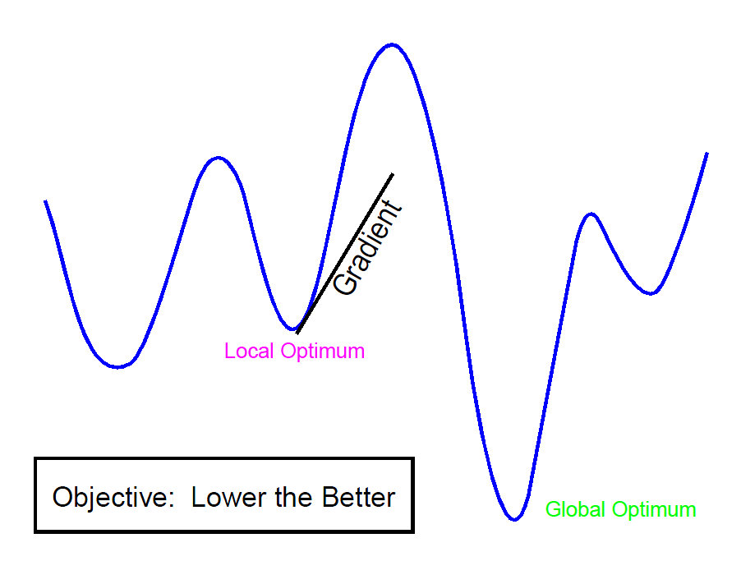

*Figure 1. Local & global optima*

**Acceptance probability**

In simulated annealing algorithm that has applied to the discreet optimization problem, the objective function generates two solutions on each iteration. One is the current solution and the other is the newly calculated candidate solution. Then it compares the two solutions based on acceptance probability. Therefore, “Acceptance probability” in simulated annealing is criteria that the candidate solution is accepted to be a current solution. The acceptance probability only allows the improving solution as accepted solution. But, there is an exception that the non-improving solution might be accepted in such a way that can skip the local optima so that it goes forward and look for the global optima.

**Cooling schedule**

With the analogy of solids annealing, cooling schedule can be defined in three variables: initial temperature, a schedule for reducing the temperature in the iterations and stopping criteria. In simulated annealing the effective design of the cooling system will reduce the time taken by the algorithm to reach the optimal solution.

Homogeneous simulated annealing convergence theory is used to design effective cooling schedule with the following procedures:

1. Start with initial temperature of t0, for which a good approximation of possible solution is reached quickly
2. Reduce t0 to t to compare the approximated change
3. Keep the temperature constant during the iteration needed for the solution distribution to approximate the out come of the change in t

And the iteration will continue until no further improvement seems possible

**Working principles of simulated annealing**

Lets first take a look at different term and definitions of simulated annealing before we talk about the principle and algorithms of simulated annealing.

Solution space (Ω)- sets of all possible solutions,

Objective function (f)- defined on the solution space under real number

Neighborhood function (N)- for all ω ε Ω there exist N(ε ) is the associated neighboring solution.

Global minimum (ω*)- the global minimum point given that the objective function f

Then our objective is to find the global minimum such that ω*ε Ω, such that f(ω)>f(ω*) for allω ε Ω

The simulated annealing algorithm searches for global minimum points, ω*ε Ω, in several iterations starting with initial solution. Then the neighboring solution ω’ is then generated based on the predefined criterion or randomly. After comparing the ω’ and ω based on the acceptance criteria, the current solution (state) which is ω ε Ω will be moved to the candidate solution, ω’ ε N(ω) if the candidate solution improves the current solution or if it encounters the local optima. This kind of skipping a local optima in simulated annealing is called hill-climbing.